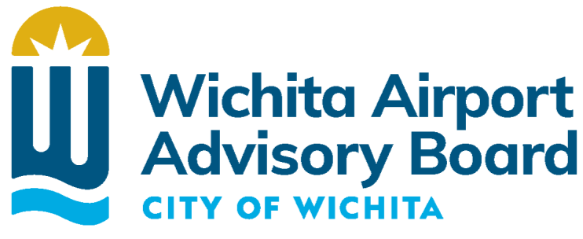

Agenda
Monday, July 10, 2023, • 3:00 p.m.
In Person and Virtual Meeting • Zoom
• • • • • • • • • • • • • • • • • • • • • • • • • • • • • • • • • • • • • • • • • • • • • • • • • • • •

Call to Order
Approval of Minutes of June 5, 2023, Meeting
Public Agenda
- Notice - No action will be taken relative to items presented on this public agenda other than referral for information. This portion of the meeting is limited to thirty minutes and shall be subject to a limitation of five minutes for each presentation. Matters pertaining to personnel, litigation, and violations of laws and ordinances are excluded from this public agenda.

Director’s Report
- Board elections
- FAA 139 Inspection complete
- Air Service update
- Project Updates
  - GA Apron
  - CBP facility improvements
  - ALOFT grant
  - RAISE grant

Staff Reports
- Operating Budget & CIP

Other Business

Adjournment
- The next regular Wichita Airport Advisory Board meeting is scheduled to be held, at 3:00 p.m. on Monday, August 7, 2023.

